APPENDIX-1

**TITLE OF PROJECT**

Pension and Commutation Calculator

**END TERM REPORT**

by

**Danda Shashidhar Reddy,**

**Nelanti Arun Kumar,**

**Pappur Harsha Vardhan Reddy**

Section:- K19PG

Roll Numbers:- 2, 8 ,28



**Department of Intelligent Systems,**

**School of Computer Science Engineering,**

**Lovely Professional University, Jalandhar**

November ,2020

1

APPENDIX-2

**Student Declaration**

This is to declare that this report has been written by us. No part of the report is copied from other sources. All information included from other sourceshave been duly acknowledged.We aver that if any part of the report is found to be copied, we are shall take full responsibility for it.

Signature:

**Name**:Shashidhar Reddy,

Arun Kumar ,

Harsha vardhan reddy

**Roll Number:**2, 8, 28.

**Place**: Phagwara

**Date:** 20-10-2020.

APPENDIX-3

**TABLE OF CONTENTS**

**TITLE:-**Pension and commutation calculator for bank employees

Page no.

|  |  |
| --- | --- |
| **1. Background and objectives of project assigned ................** | **1-3** |
| **1.1 Background** | 1 |
| **1.2 Motivation**  **1.3 Learning outcome** | 2  3 |
| **2. Description of Project ...........................................................**  **2.1 Description**  **2.2 Formula**  **2.3 Test cases used**  **3.Bibliography…………………………………………………**  **4. Conclusion…………………………………………………..** | **4-14**  **4-12**  **13**  **14**  **15** |
|  | **16** |
|  |  |

APPENDIX-4

**BONAFIDE CERTIFICATE**

Certified that this project report “Pension and commutation calculator for bank employees ” is the bonafide work of “DandaShashidhar Reddy, NelantiArun Kumar, PappurHarshavardhan Reddy” who carried out the project work under my supervision.

### <<Signature of the Supervisor>>(Due to Covid 19, signature is exempted )

### Dr.Dhanprathapsingh

### Associate Professor,

### 25706

### Department:- Intelligence

### System

### LPU

### Phagwara,Panjab

**Background**

Python is a programming language developed in year 1989 by Guido van Rossum at Centrum Wiskund&Informatica. Though it has emerged as a leading language just few years back. Python programs are easy to understand and are almost in plain English. Anyone who does not have prior knowledge of programming can also understand its program. We have been learning python in 3rd semester.

As for the assignment, My assignment is design a project of for”Pension and commutation calculator for bank employees”. We decided to divide the work between the three of us.So we each took a different role in the project like one has collected all the modules and tools that are required and the other has designed the GUI and other took the test cases to check whether the project is working or not.

After doing the base work. We had decided to start the coding which became easy because we already decided which tools and widgets that we are going to use in the program.

Our testing phase took much longer time because we had to check for every value and see if there is any bug. It took longer than we expected but we had finished the work way before the deadline.

**Motivation**

We are interested in coding and we also want to learn coding. So we thought this project is a good chance to learn it. Python is easy language compare to others. Our lecturer said about GUI(graphical user interface) and we got more interest in it. We divided our work into ourselves and it became quite easy for us to complete our work on time. As we could not meet physically, hence we had decided and made the whole project online through talking on phone. Our sole motivation for making this project was that we got to learn a lot about the python and tkinter, about their working.

For the successful completion of this project, we had been helped by many individuals along the way. Our teacher, Dr.Dhanpratap Singh helped us a lot, he cleared every doubt we are having about the project, whenever we asked him a doubt, without hesitating sir had answered to ourqueries. Our friends also helped us a lot and they also had been a constant source of our motivation

**Learning outcome**

By the time of completion of the project, we learnt about python, we learnt various properties of tkinter ,we learnt various alignments , different uses, widgets and how to take input/output from GUI. The biggest outcome of the project was, we came to know all the concepts of python tkinter. We now have full grip over almost all the concepts of tkinter, as we had implemented all the widgets of python.

We also learnt about how to make the program i.e., firstly designing, then coding and then testing the project. We learnt all the widgets of python and their implementation and working. We learnt about what features go with each widget and where to place them.

**Description**

Our project is “Pension and commutation calculator for bank employees”. For this we have to make the front window /root window. The front window is consist of the heading as “pension and commutation calculator for the bank employee”. And in the below, there will be 2 buttons having options to choose between whether the bank employee want regular retirement or voluntary retirement. As the age of the employee is 60 years for the regular retirement. Employee can choose as per his/ her requirement.

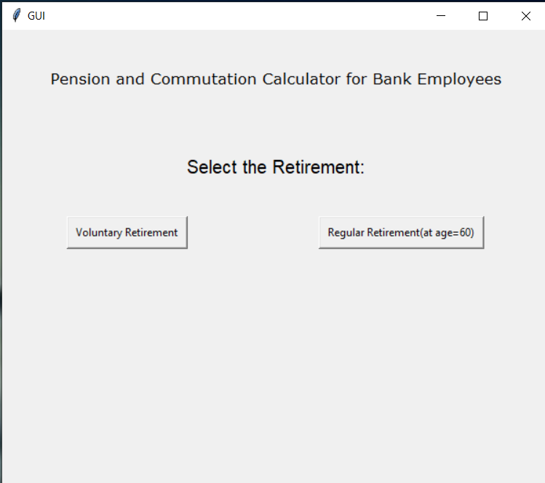

After opening the window that shown above, we have to select particular button as per the age. If the employee age is 60 years, then he/she has to select Regular Retirement. If the age of the employee is below 60 years then the employee has to select the Voluntary Retirement.

By selecting the buttons ,we will processed to 2 different windows.

**Points to be remembered while filling the details:**

* The total number of years of service , Basic pay, DA(dareness allowance), commute are must be the numeric values ,But not in the variables, special characters, mathematical symbols .
* Make sure that , before submitting the values to the system, confirm that all the details must be filled.
* Dareness Allowance is must be in percentage.
* If the selection is regular retirement, the the employee will processed to the next window which the user required to provide the details of the employee like total number of years of service, Basic pay at the time of retirement , Dareness Allowance , and also we have to provide the commute . Then after providing all the required details ,then the user click the submit button which provided at the bottom.

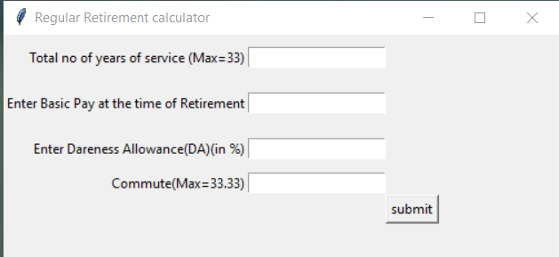

* In this, the total number of years of service is maximum 33 years;
* If the total numbers of years of service is below 33 ,then the system will take the value that the user have entered.
* But ,if the total numbers of years of service is above 33, then the system will take the value as 33years.
* The Dareness Allowance is must be in percentage.
* The maximum commute is 33.33 .
* From this window , there is chance to have 2 windows:

1. For valid input.
2. For invalid input.

* **For valid input:**
* After entering all the values , and it will be:

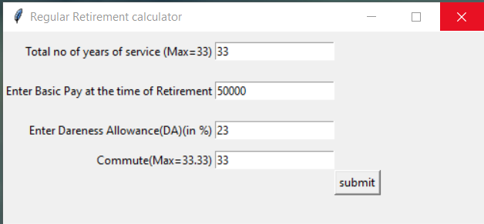

* After submitting the values to the system, we will get the alert box, to enter only values:

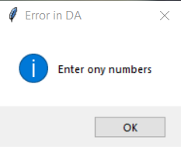

* After clicking “**OK”** then the system shows the result:
* The result is containing the calculated values of Gross Pay, Commutation, Monthly Pension.

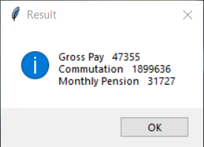

* **For invalid inputs:**
* For suppose , after entering the invalid inputs to the system:

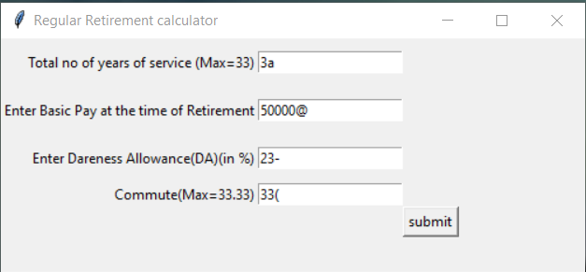

* After submitting the invalid values as like shown in the figure above, first we get an **error in service years.**

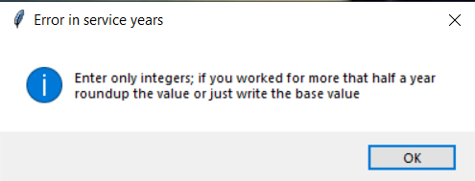

* By clicking “**OK**” in the above figure , we get**error in basic pay**by showing error message as ‘Enter only numbers or integers’.

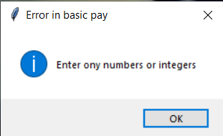

* By clicking “**OK**” in the above figure , we get **error in DA** by showing error message as ‘ Enter only numbers’.

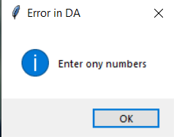

* By clicking “**OK**” in the above figure , we get **error in commute** by showing error message as ‘ Enter only numbers’.

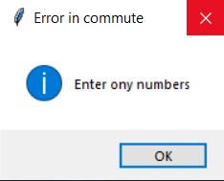

* By clicking “**OK**” in the above figure, then the window will be closed and we will be on the window that we have submitted the invalid inputs. Then by changing the invalid values to valid details then the user will get the calculated values of Gross Pay, commutation and monthly pention.
* **The above steps is followed by the system ,when the user choosing the Regular Retirement.**
* If the selection is Voluntary Retirement, then the employee will processed to the next window which the user required to provide the details of the employee like total number of years of service, Age at the time of retirement, Basic pay at the time of retirement , Dareness Allowance , and also we have to provide the commute . Then after providing all the required details ,then the user click the submit button which provided at the bottom.

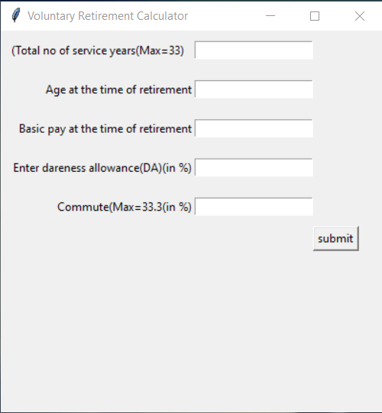

* In Voluntary retirement the system wants to know Age at the time of retirement, because, to find the Age-rate of the employee at the particular age when the employee wants to retire.

For finding the age rate we inserted the dictionary to the code.

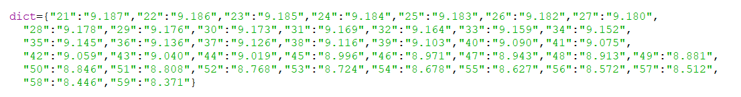

* For regular retirement ,the age of the employee at retirement is fixed(=60) , so the age rate is fixed(i.e; 10.13).
* From this window , there is chance to have 2 windows:

1. For valid input.
2. For invalid input.

* **For valid input:**
* After entering all the values , and it will be:

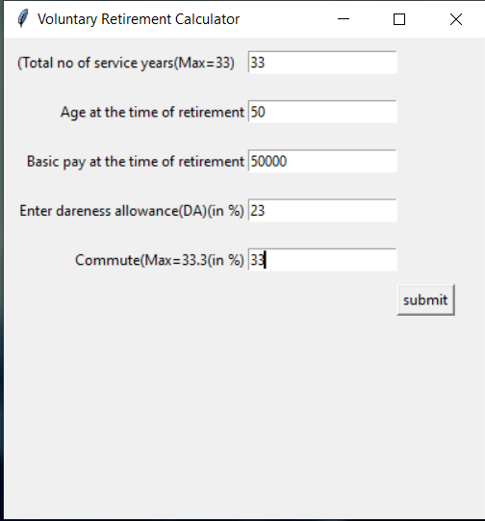

* After submitting all the values to the system, we will get the result window that containing the calculated values of age rate, gross pay, commutation, monthly pension.

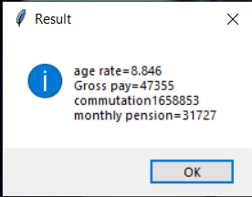

* **For invalid inputs:**
* For suppose , after entering the invalid inputs to the system:

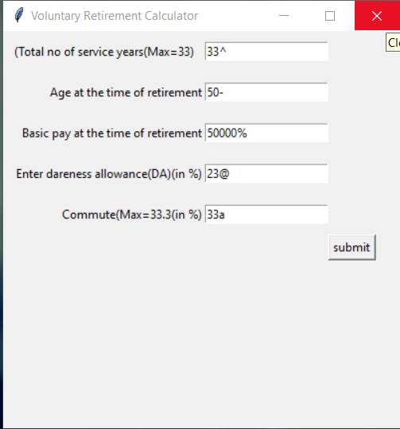

* After submitting the invalid values as like shown in the figure above, first we get an **error in service years.**

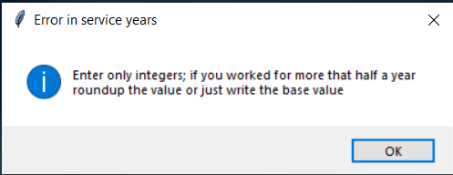

* By clicking “**OK**” in the above figure , we get **error in basic pay**by showing error message as ‘Enter only numbers or integers’.

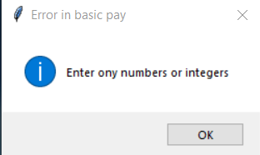

* By clicking “**OK**” in the above figure , we get **error in DA** by showing error message as ‘ Enter only numbers’.

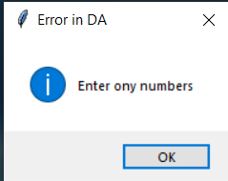

* By clicking “**OK**” in the above figure , we get **error in commute** by showing error message as ‘ Enter only numbers’.

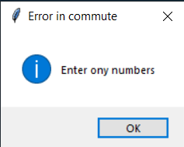

* By clicking “**OK**” in the above figure , we get **error in retirement age** by showing error message as ‘ Enter only numbers, Enter the age at which you retired’.

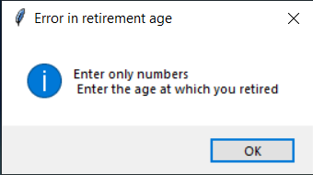

* By clicking “**OK**” in the above figure, then the window will be closed and we will be on the window that we have submitted the invalid inputs. Then by changing the invalid values to valid details then the user will get the calculated values of Gross Pay, commutation, age rate and monthly pention.
* **The above steps is followed by the system ,when the user choosing the Voluntary Retirement.**

**FORMULA**

* The formula to be used to calculate **Gross-pay** is:

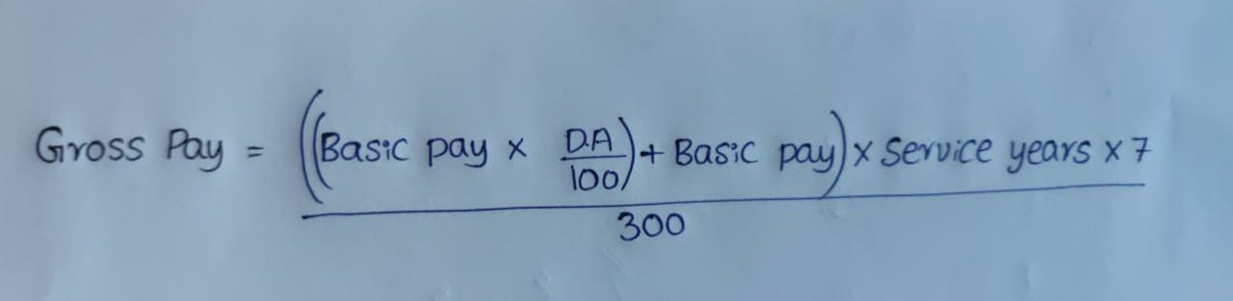

* The formula to be used to calculate **Commutation** is:

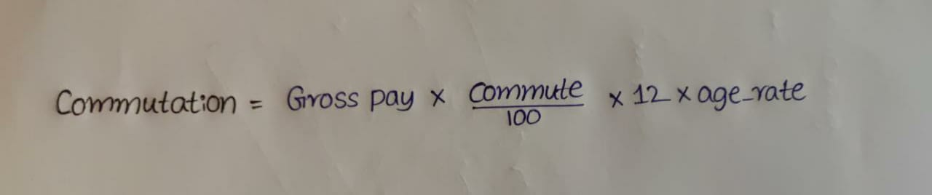

* The formula to be used to calculate **Monthly Pension** is:



**Test cases used**

In our project “Pension and commutation calculator for bank employees” we have used so many test cases for testing the output.

1. Firstly, we have checked for the valid inputs ,that is; for the numeric values and integers we should get the output, and for the invalid inputs like variables, special characters and for the mathematical expressions we should get the error box should pop-up.
2. We have checked for some of the input values to formulae on the paper for the manual calculation, and we noted the value calculated manually. And after using the code ,we checked for the results for the same details. And we cross-checked both of the results. The program is giving exact result as we got by manual.

* We are getting the desired output for the input values. So , the code is working properly and the code is tested successfully.

**Bibliography**

While completing the project we also had a few doubts some of them were cleared by our lecturer and for the other some we had took reference from some of the best online sites. Those are:

<https://www.geeksforgeeks.org/python-gui-tkinter/>

<https://www.javatpoint.com/python-tkinter>

<https://www.tutorialspoint.com/python/python_gui_programming.htm>

<https://www.geeksforgeeks.org/python-exception-handling/>

**Conclusion**

This project took a lot of time to complete because, before completion of the project , we need to prepare and study hard to create the GUI and only because of this it helped us to gain knowledge on using tkinter in python.

Our project was to calculate the monthly pension and commutation of a bank employee. Here we made a opening window for the users option whether he /she retired at Regularly (or) Voluntary at an early age.

If he/she selects the Voluntary Retirement i.e., if he/she retires for the job before the retirement age then we need to find the age-rate of the employee at the retirement age , so we made a dictionary which take age as the key-word and gives age-rate to system as an value and calculates the Gross-pay, monthly pension and commutation accordingly.

We think that the calculation has no error; key shows no problem while calculating them.

**GitHub repository link**

<https://github.com/Harsha733/Pension-and-Commutation-Calculator-for-bank-employess>